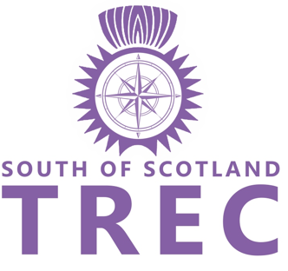
South of Scotland TREC
Membership Application
2021/2022

Membership runs from 1st October 2021 to 30th September 2022

Name ……………………………………………………………………………………….

Address…………………………………………………………………………………………………………………………………….

………………………………………………………………………..........................................................................................

Home Tel …………………………………………………………………………………

Mobile Tel…………………………………………………………………………………

E mail………………………………………………………………………………………..

D.o.B (if under 22)……………………………………………………………………..

Type of membership applied for: (Please tick)

Riding Membership (Adult or Junior) £20.00

Riding Membership (Junior - under 18) £10.00

Supporter Membership Free

I do not object to data relating to me being held by South of Scotland TREC. I agree this data may be disclosed to TREC GB

Signature: …………………………………………………………………………………..

Signature of Parent/guardian (If under 18): ………………………………………………………………………………

Date: ………………………………………………………………………………………….

Please complete and send your cheque payable to South of Scotland TREC to:
Sheila Watson
Marks
Kirkcudbright
Dumfries and Galloway
DG6 4XR

Or email form to : smwatson07@icloud.com

And send your payment by BACS or faster payment to: Bank of Scotland 80 22 60 / 1527 8467
Using your NAME as reference

