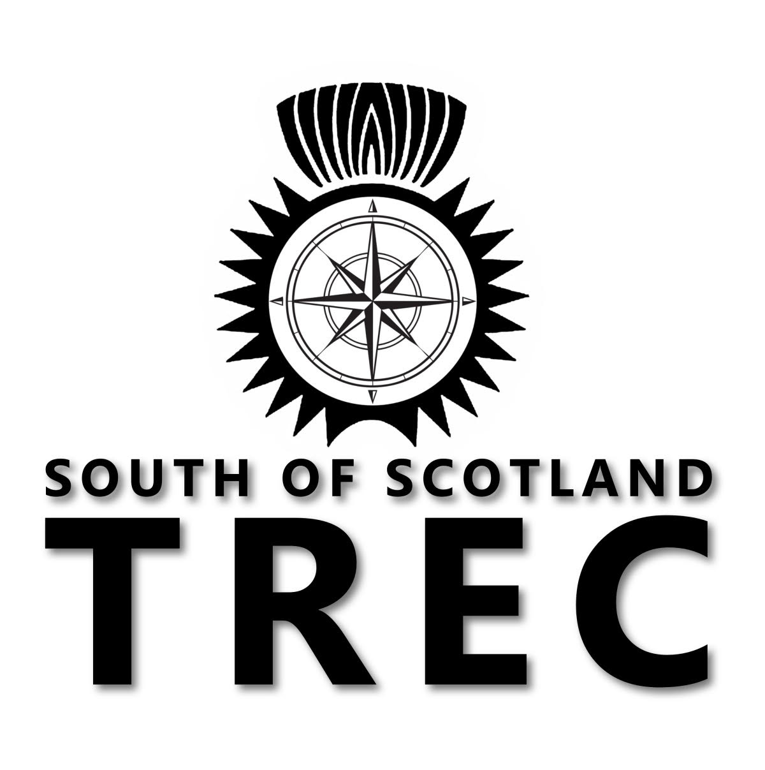

South Of Scotland TREC
Summer Camp and 10/10 competition
25th to 27th June 2021
Hyndshawland Farm Stables
Elsrickle
ML12 6RD

We are on our way back. Time to get back out there training and competing. Please join us at our training camp and one day 10/10 competition.
We have lots of fun and interesting things planned for you.
Below is a rough guide to a timetable of events. (subject to change)
Friday 25th June
Arrive between 10am and 1pm
2pm to 5pm Map reading sessions
Evening meal (supplied as part of the weekend.)and socially distanced social.
After dark night navigation fun
Saturday 26th June
9am to 12.30 Ride with your Mind instruction and coaching
MA and PTV training
1pm to 2pm Lunch break. (Bring your own)
2.30pm to 6pm Ride with Your Mind instruction and coaching
MA and PTV training
Evening meal(bring your own food and drink) and relax (maybe a BBQ if Covid restrictions and guidance allow)
Sunday 27th June
All day: 10/10 3 phase, one day Trec competition and prize giving. (Hopefully finished up for 4pm)
The final details are being put together for a really exciting and fun filled weekend.
South of Scotland TREC members get first refusal for places. Entries open on the 8th May exclusively to SoS members and then entries open to all from 19th May up until the 26th May when entries close.
A waiting list will be held if we are oversubscribed. Your place will not be secured until payment is made.
No dogs and no stallions.
The cost of the camp is £250 for SoS members and £270 for non members (if there is room after the 19th May) which includes corralling, all tuition, fun activities and entry to the 10/10 competition on 27th June. There are no stables available on site. In past years the kitchen at Hyndshawland has been at your disposal for making your own breakfast and lunch. This unfortunately will not be available this year due to Covid restrictions but we will be making the hayshed, opposite the kitchen available for our socially distanced gatherings. It is classed as an outdoor space as it has a roof and only 2 sides.
To gain the most from your experience, we have secured top trainers to train and coach you with the emphasis on fun and inclusion. All levels will be catered for. Helen Wain (RWYM trainer, TD, judge and coach) and Sheila Watson (TREC trainer, judge, organiser, tracer and International rider.)
You are welcome to stay in your lorries/ trailers or camp. Please state which on your booking form. There are separate entry forms for camp and the 10/10. Although it is all included in the camp, the paperwork requires two entry forms. One for each. Please make sure you fill out both and send in together.
Human water will be made available from the house.
Numbers are limited to enable you to get the most out of the weekend, so please send your application form in before the closing date of the 26th May to secure your place.
Should you have any questions, please do not hesitate to contact Dot on still.dorothy@gmail.com or pm Dot via facebook.
We are really looking forward to seeing you.
Joining details and further notes regarding covid safe procedures will be sent to all those participating

SoS TREC Camp

Booking Form
25th to 27th June 2021

Name:

Address:

Phone Number:
Mobile Number:
E mail:
Polo shirt size:

Emergency Contact / Next of Kin Name:
Phone number:

Trec Experience:

Any other relevant information ( dietary or otherwise):

Please send fee of £250 (members) or £270 (non members)to:
South of Scotland TREC
Bank of Scotland
80-22-60
15278467

Please use your surname followed by CAMP in the reference box.

Anyone under the age of 16 must have the consent of an adult and be accompanied by an adult and the relevant paperwork must be completed.
Email your booking form to: still.dorothy@gmail.com

Cancellation policy:
If you cancel, we will try our best to fill your space and issue you a full refund minus a £20 admin fee. In the event we cannot the following scale of cancellation fees will apply.
Cancel within 7 days of event, 20% refund
Cancel within 14 to 7 days of event 50% refund
Cancel within 21 to 15 days of event 70% refund
Cancel before 22 days of the event 90% refund
If SoS TREC cancel due to Covid or any other reason an admin fee of £10 will be taken and the rest refunded to you.

